**PIZZA SALES REPORT**

1. **Total Revenue**

SELECT SUM(total_price) AS Total_Revenue FROM pizza_sales_excel_file

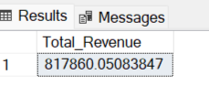

1. **Average Order Value**

SELECT SUM(total_price)/COUNT(DISTINCT order_id) AS Avg_Order_Value FROM pizza_sales_excel_file

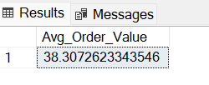

1. **Total Pizzas Quantities sold**

SELECT SUM(quantity) AS Total_Pizza_Sold FROM pizza_sales_excel_file

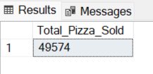

1. **Total Orders placed**

SELECT COUNT(DISTINCT order_id) AS Total_Orders FROM pizza_sales_excel_file

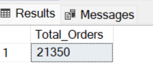

1. **Average Pizzas per order**

SELECT CAST(CAST(SUM(quantity) AS DECIMAL (10,2))/

CAST(COUNT(DISTINCT order_id) AS DECIMAL(10,2))AS DECIMAL(10,2)) AS Average_Pizzas_Per_order FROM pizza_sales_excel_file

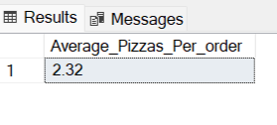

1. **Hourly Trend for total Pizzas sold**

SELECT DATEPART(HOUR,order_time) AS order_hour, SUM(quantity) AS Total_Pizzas_Sold

FROM pizza_sales_excel_file

GROUP BY DATEPART(HOUR,order_time)

ORDER BY DATEPART(HOUR,order_time)

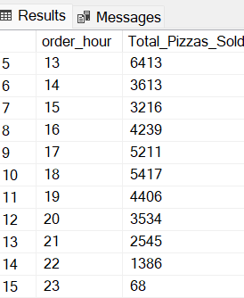

1. **Weekly Trend for total Pizzas sold**

SELECT DATEPART(ISO_WEEK, order_date) AS week_number, YEAR(order_date) AS Order_Year,COUNT(DISTINCT order_id) AS Total_Orders

FROM pizza_sales_excel_file

GROUP BY DATEPART(ISO_WEEK, order_date),YEAR(order_date)

ORDER BY DATEPART(ISO_WEEK,order_date),YEAR(order_date)

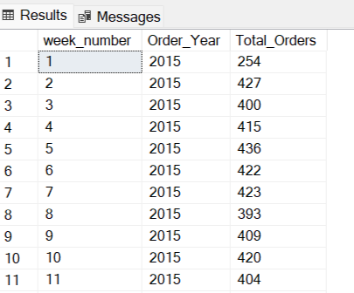

1. **Percentage of Sales per pizza category (For 1 month)**

SELECT pizza_category,SUM(total_price) AS Total_Sales,

sum(total_price)*100/(SELECT sum(total_price)FROM pizza_sales_excel_file

WHERE month(order_date)=1) AS PCT

FROM pizza_sales_excel_file

WHERE month(order_date)=1

GROUP BY pizza_category

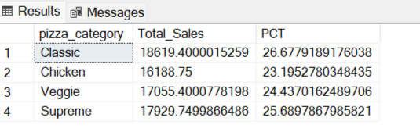

1. **Percentage of Sales by Pizza size (for quarter)**

SELECT pizza_size,CAST(SUM(total_price) AS DECIMAL(10,2)) AS Total_Sales,

CAST(sum(total_price)*100/(SELECT sum(total_price)FROM pizza_sales_excel_file WHERE DATEPART(QUARTER, order_date)=1) AS DECIMAL(10,2)) AS PCT

FROM pizza_sales_excel_file

WHERE DATEPART(QUARTEr, order_date)=1

GROUP BY pizza_size

ORDER BY PCT DESC

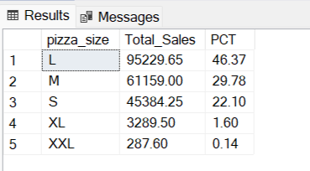

1. **Top 5 Pizzas by Revenue**

SELECT TOP 5 pizza_name, SUM(total_price) AS Total_Revenue

FROM pizza_sales_excel_file

GROUP BY pizza_name

ORDER BY Total_Revenue DESC

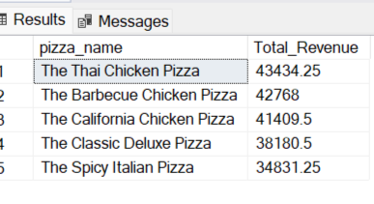

1. **Bottom 5 Pizzas by Revenue**

SELECT TOP 5 pizza_name, SUM(total_price) AS Total_Revenue

FROM pizza_sales_excel_file

GROUP BY pizza_name

ORDER BY Total_Revenue

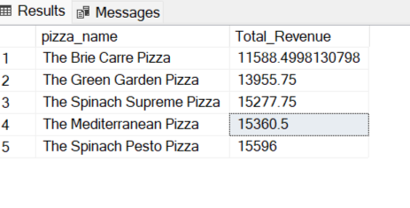

1. **Top 5 Pizzas by Quantity**

SELECT TOP 5 pizza_name, SUM(quantity) AS Total_Quantity

FROM pizza_sales_excel_file

GROUP BY pizza_name

ORDER BY Total_Quantity DESC

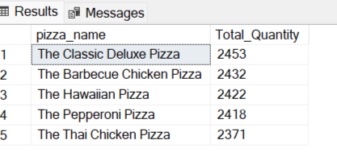

1. **Bottom 5 Pizzas by Revenue**

SELECT TOP 5 pizza_name, SUM(quantity) AS Total_Quantity

FROM pizza_sales_excel_file

GROUP BY pizza_name

ORDER BY Total_Quantity

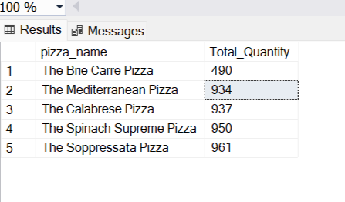

1. **Top 5 Pizzas by Order Quantity**

SELECT TOP 5 pizza_name, COUNT(DISTINCT order_id) AS Total_Orders

FROM pizza_sales_excel_file

GROUP BY pizza_name

ORDER BY Total_Orders DESC

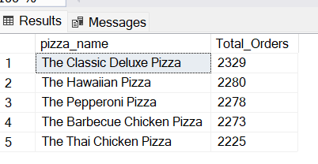

1. **Bottom 5 Pizzas by Order Quantity**

SELECT TOP 5 pizza_name, COUNT(DISTINCT order_id) AS Total_Orders

FROM pizza_sales_excel_file

GROUP BY pizza_name

ORDER BY Total_Orders

